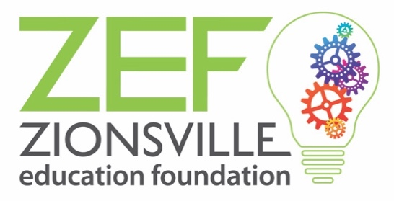

ZEF Classroom Grant Final Report Information

Dear ZCS Educator:

Congratulations on receiving a Fall or Spring Classroom Grant from the Zionsville Education Foundation! We hope it was a rewarding project for you and your students. Our mission is to serve Zionsville Community Schools “by providing funds that promote academic excellence,” and we are eager to share your success stories with our stakeholders.

ZEF Classroom Grants fund projects that promote educational excellence and are often innovative. However, we understand that innovation isn’t always smooth or perfect; they can work well the first time, require adjustments along the way, or, in some circumstances, simply don’t work as intended. In filling out your Final Report, we encourage you to be frank in your assessment of your project by letting us know what worked well, what challenges you encountered along the way, and what didn’t go as planned. Your comments will not affect the funding of your future grant applications.

A final report is due to ZEF the earlier of 30 days after the end of your grant or a maximum of a year after the grant is awarded according to the timeline below. These evaluations are critical to ZEF as we share results with our donors and sponsors.

Fall Classroom Grants – October 15th
Spring Classroom Grants – May 15th

Please fill out the following form and return to Lyle Browne at the ZEF office. You are welcome to send it via email to lbrowne@zcs.k12.in.us or via interschool mail to the ESC at 900 Mulberry Street. If you have any questions or concerns, please don’t hesitate to contact Lyle at 317.733.4805 or via the email above.

Many thanks for the hard work and extra effort you put into making this grant a reality for your students. We are grateful for the work you do!

Sincerely,
The ZEF Board and Staff

Zionsville Education Foundation
ZEF Classroom Grant Final Report Form

Grant title: ________________________________________________________

Project director(s): ___________________________________________________

School(s): _______________________________________________________________

Grant information:
Year awarded: _______
_____ Spring Classroom Grant
_____ Fall Classroom Grant

Date(s) grant implemented: _____________________________________________

- Please tell us about the successes, challenges, and/or unplanned outcomes of your project. What was the greatest impact on your students? Would you do the project again and/or recommend it to a colleague? If so, what would you change? If not, why would you not recommend it?

- Do you have any quantitative results or statistics from your grant that you can share with ZEF?

- Were there any changes to the grant’s application budget or any excess funds? If so, please submit a final budget and explain any changes. We appreciate your stewardship of all grant funds.

- What method(s) of communications did you use to publicize your receipt of this grant, the grant in action, and/or the results of the grant? Please attach copies of your communications where available and send electronic copies of any photos from the project that can be used by ZEF for public relations purposes to Lyle Browne at lbrowne@zcs.k12.in.us. Please also check with your guidance office to ensure all students pictured have signed photo releases.

Revised 7.22.19

